Audition/Biography Information
Name:

Address:

Cell Phone: |  | Home Phone:
Email Address:

Vocal Range:

In which role(s) are you interested?
Male Roles |  |  | Bill Slank/Hawking Prawn
 | Boy/Peter |  | Captain Robert Falcon Scott
 | Black Stache |  | Male Ensemble (if added)
 | Smee | Female Roles
 | Lord Leonard Aster |  | Molly Aster
 | Ted |  | Female Ensemble (if added)
 | Prentiss | Are you willing to accept ANY role?  Yes ____ No____  (Be Honest!)  Are you willing to change the color and/or  style of your hair?  Yes____ No____
Mrs. Bumbrake
(would also audition females for this role)
 | Alf
 | Fighting Prawn/Grempkin

Are you interested in becoming a member of the Actors Guild of Parkersburg? YES________________
Are you interested in technical work? Yes____ No ____
If so, in what area(s)? _______________________________
PETER AND THE STARCATCHER CONFLICT CALENDAR
PLACE AN "X" THROUGH ANY DAY YOU HAVE A CONFLICT
Please list ALL your scheduled conflicts during the rehearsal time frame of October 22 to January 10, 2018. Indicate afternoon/evening conflicts for Saturdays & Sundays. Honesty about conflicts is the best policy. If you have NO CONFLICTS or a REOCCURING CONFLICT (ex: work schedule, church obligations) please indicate such in the comments section. Performance dates are January 12, 13, 14, 19, 20, and 21 2018.

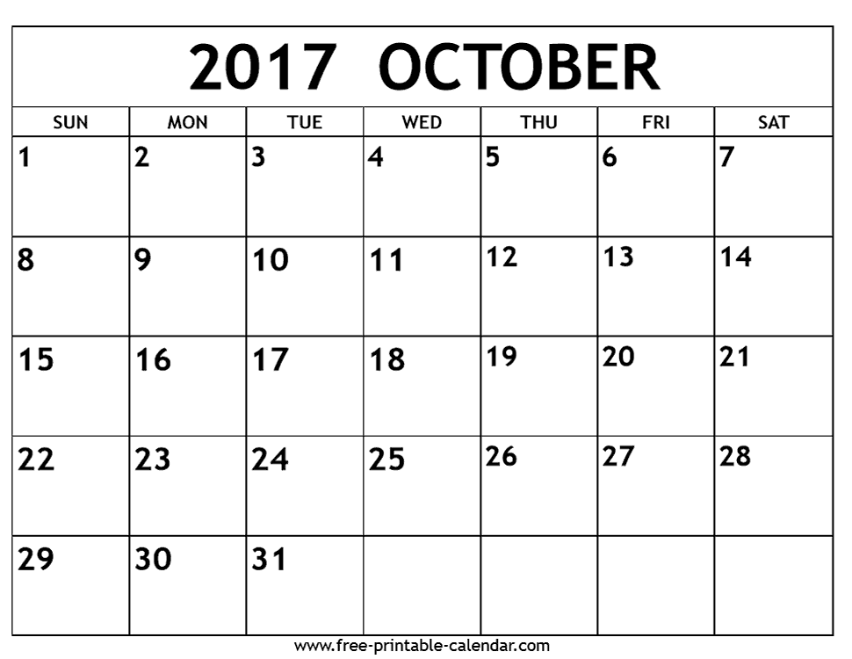
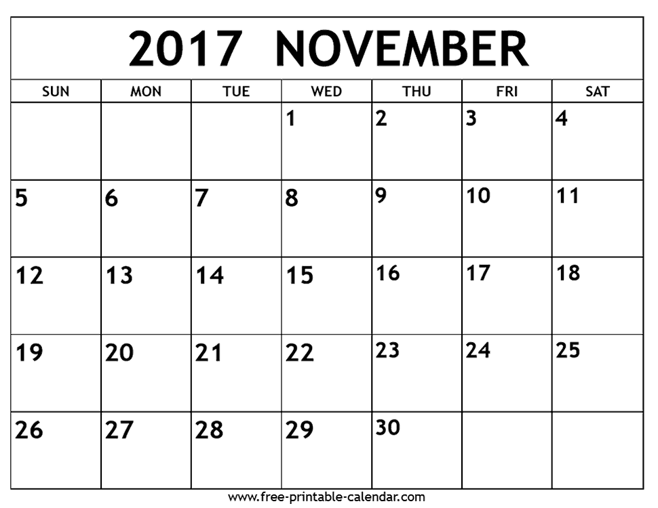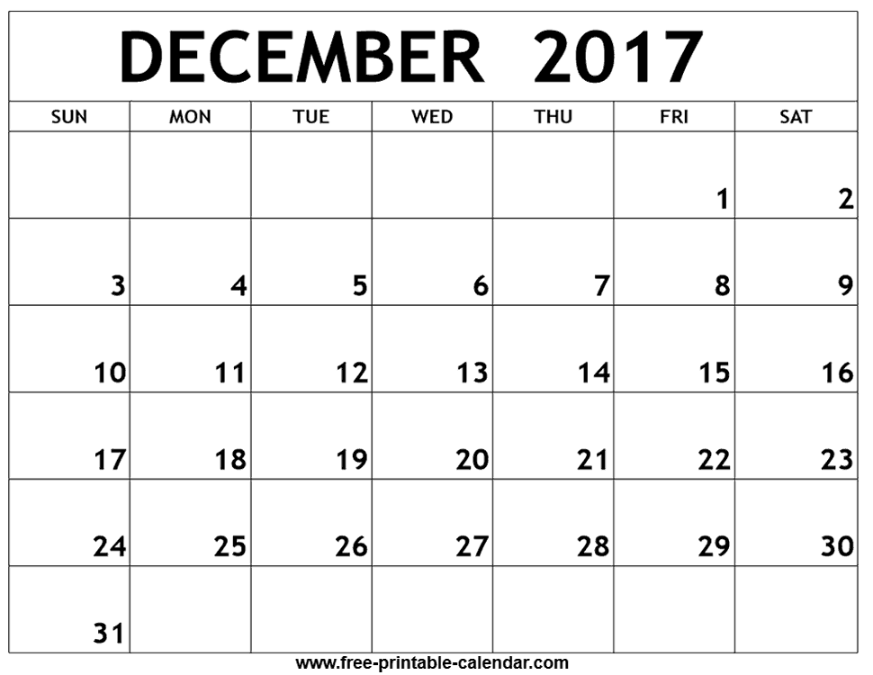
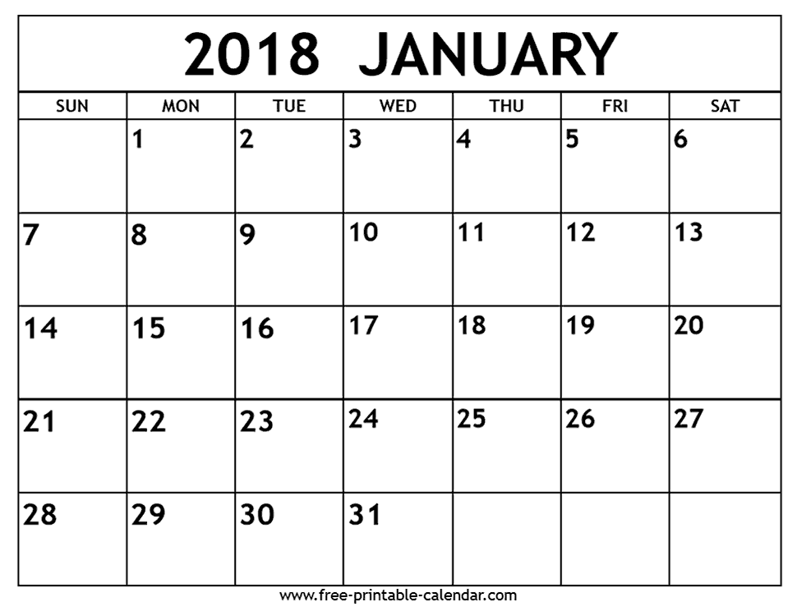
Comments:

